An internship in
Google Cloud Generative AI
by
SmartInternz
Project Name : Gemini Pro Financial Decoder: Transforming Complex Data into Actionable Insights
Project Id : LTVIP2026TMIDS71823
Project Mentor : O Homa Kesav
Team Members and Roles:
- Kuruva Pakkirappa Gari Swetha - Team Leader / Project Manager

- Patan Arshiya - Frontend & UI Developer

- Kille Naresh - Backend & API Developer

- Shaik Suhail - AI & Data Analyst



Annamacharya Institute of Technology & Sciences, Utukur (Post), Chinthakomma Dinne (V&M), Kadapa, YSR (Dist) Andhra Pradesh

ACKNOWLEDGEMENT
I am pleased to acknowledge my sincere thanks to Institute of ANNAMACHARYA for their kind
encouragement in doing this project and for completing it successfully. I am grateful to them.
I convey my thanks to Dr. A. Sudhakar Reddy, principal of Annamacharya Institute of technology and sciences and Engineering for providing me necessary support and details at the right time during the progressive reviews.
I would like to express my sincere and deep sense of gratitude to my Project mentor O Homa Kesav for his valuable guidance, suggestions and constant encouragement pavedway for the successful completion of my project work.

ABSTRACT
In today’s data-driven financial environment, organizations and individuals generate large volumes of complex financial data that are often difficult to interpret accurately and efficiently. Traditional financial analysis methods are time-consuming, require expert knowledge, and are prone to human error. This project, Gemini Pro Financial Decoder, proposes an AI-powered solution that transforms complex financial documents into clear, actionable insights to support informed decision-making.
The system leverages Gemini Pro, a large language model, to analyze financial statements such as balance sheets, income statements, cash flow reports, and market data. Uploaded financial documents are preprocessed, structured, and interpreted to extract key metrics, identify trends, detect risks, and generate easy-to-understand summaries. The solution provides a user-friendly web interface that enables users to upload documents, ask natural language queries, and visualize insights through charts and reports.
The proposed system ensures high performance, scalability, security, and usability while maintaining data privacy. By simplifying financial analysis and making insights accessible to both finance and non-finance users, the Gemini Pro Financial Decoder reduces analysis time, improves accuracy, and enhances confidence in financial decision-making. This project demonstrates the effective application of generative AI in financial analytics and decision support systems.

Project Report Format

INTRODUCTION
  - Project Overview
  - Purpose

IDEATION PHASE
  - Problem Statement
  - Empathy Map Canvas
  - Brainstorming

REQUIREMENT ANALYSIS
  - Customer Journey map
  - Solution Requirement
  - Data Flow Diagram
  - Technology Stack

PROJECT DESIGN
  - Problem Solution Fit
  - Proposed Solution
  - Solution Architecture

PROJECT PLANNING & SCHEDULING
  - Project Planning

FUNCTIONAL AND PERFORMANCE TESTING
  - Performance Testing

RESULTS
  - Output Screenshots
- ADVANTAGES & DISADVANTAGES
- CONCLUSION
- FUTURE SCOPE
- APPENDIX
Source Code(if any) Dataset Link
GitHub & Project Demo Link

INTRODUCTION

Project Overview
The Gemini Pro Financial Decoder provides a user-friendly platform where users can upload financial documents and receive clear summaries, key financial metrics, risk indicators, and actionable recommendations. The system preprocesses financial data, applies intelligent analysis using Gemini Pro, and presents insights through interactive visualizations and downloadable reports.
This project aims to reduce manual effort, minimize errors in financial interpretation, and make financial insights accessible to both finance professionals and non-finance users. By integrating modern web technologies with advanced generative AI, the Gemini Pro Financial Decoder supports faster, more accurate, and confident financial decision-making, demonstrating the practical application of AI in financial analytics.

Purpose
The purpose of the Gemini Pro Financial Decoder project is to design and develop an intelligent system that simplifies the analysis of complex financial data and converts it into meaningful, actionable insights. Financial reports and statements often contain large volumes of numerical and textual information that are difficult to interpret, especially for non-finance users. This project aims to bridge the gap between raw financial data and informed decision-making.
The system leverages the power of Gemini Pro, a large language model, to automatically analyze financial documents such as balance sheets, income statements, cash flow reports, PDFs, and spreadsheets. By doing so, it reduces manual analysis effort, minimizes human errors, and improves the speed and accuracy of financial interpretation.
The overall purpose is to provide a user-friendly, secure, and scalable solution that enables business owners, analysts, investors, and non-finance professionals to understand financial performance, identify risks, and make confident, data-driven decisions without requiring deep financial expertise.

IDEATION PHASE

Define the Problem
In the current financial landscape, organizations and individuals generate large volumes of financial data in the form of balance sheets, income statements, cash flow reports, and market documents. These documents are often complex, unstructured, and filled with technical terminology, making them difficult to interpret accurately. Manual financial analysis is time- consuming, requires expert knowledge, and is prone to human errors, which can lead to delayed or incorrect decision-making.
Many business owners, investors, and non-finance professionals lack access to intelligent tools that can simplify financial data and present meaningful insights in an easy-to-understand format. Therefore, there is a need for an automated, AI-driven solution that can decode complex financial data and transform it into actionable insights to support faster, more confident financial decisions.

Empathy & Discover
The empathy and discovery stage focuses on understanding the users, their challenges, and their expectations when dealing with financial data. The primary users of the Gemini Pro Financial Decoder include financial analysts, business owners, investors, and non-finance professionals.
Users often feel overwhelmed by large spreadsheets and lengthy financial reports. They struggle to identify key metrics, risks, and trends within limited timeframes. Non-finance users, in particular, face difficulty understanding financial jargon and interpreting numerical data, leading to uncertainty and hesitation in decision-making.
Through empathy mapping, it was discovered that users need a system that provides clear explanations, visual insights, and quick summaries while ensuring data security and accuracy. Understanding these user pain points helps shape a solution that is intuitive, reliable, and user- centric.

Brainstorm & Idea Prioritization
During the brainstorming phase, multiple ideas were generated to address the identified problems. These ideas included automated financial report summarization, extraction of key financial metrics, AI-based risk and anomaly detection, interactive dashboards, and natural language question-answering over financial documents.
The generated ideas were grouped and evaluated based on feasibility, user impact, and scalability. High-priority ideas included AI-powered document summarization, trend and risk analysis, and simplified natural language explanations. Features such as interactive visual dashboards and downloadable reports were also prioritized to enhance user experience.
By prioritizing ideas that offer maximum value with practical implementation, the Gemini Pro Financial Decoder was designed as an intelligent, scalable solution capable of transforming complex financial data into clear, actionable insights for diver

REQUIREMENT ANALYSIS
Requirement analysis is a crucial phase that focuses on understanding user interactions, defining system requirements, modeling data flow, and selecting appropriate technologies. For the Gemini Pro Financial Decoder, this phase ensures that the system is user-centric, efficient, secure, and technically feasible.

Customer Journey Map
The customer journey map describes the step-by-step interaction of users with the system, from accessing the platform to obtaining actionable financial insights.
    - Access Platform- The user logs into the web application using secure authentication.
    - Upload Financial Documents-The user uploads financial documents such as balance sheets, income statements, PDFs, or Excel files.
    - Data Processing - The system validates, preprocesses, and structures the uploaded financial data.
    - AI Analysis-Gemini Pro analyzes the data to extract key metrics, trends, risks, and insights.
    - Insight Visualization-The user views summaries, charts, and explanations on the dashboard.
    - Decision Support-The user downloads reports or uses insights to make informed financial decisions.

Solution Requirement

Functional Requirements
    - Upload and preview financial documents
    - Extract and analyze key financial metrics
    - Generate summaries, insights, and risk indicators
    - Provide visual dashboards and downloadable reports
    - Ensure secure handling of financial data

Non-Functional Requirements
    - High usability with simple navigation and tooltips
    - Data security and privacy compliance
    - High system availability and reliability
    - Fast response time and scalable performance

Data Flow Diagram (DFD)
The Data Flow Diagram represents how data moves through the Gemini Pro Financial Decoder system.
    - Input: Financial documents and user queries
    - Process: Data ingestion, preprocessing, AI-based analysis using Gemini Pro
    - Storage: Databases for documents, logs, and results
    - Output: Financial summaries, insights, dashboards, and reports
The DFD ensures clarity in data movement, processing responsibilities, and system boundaries.

Technology Stack
The technology stack defines the tools and platforms used to build the system:
    - Frontend: React.js / Vue.js, Tailwind CSS
    - Backend: FastAPI / Flask (Python)
    - AI Engine: Gemini Pro (Large Language Model)
    - Data Processing: Pandas, NumPy
    - Visualization: Plotly, Matplotlib
    - Database: PostgreSQL / MongoDB
    - Security: JWT / OAuth2, HTTPS / SSL
    - Deployment: Cloud platform with containerization support

PROJECT DESIGN
The project design phase focuses on mapping the identified problem to an effective solution, defining the proposed approach, and describing the overall system architecture. This phase ensures that the solution is feasible, scalable, and aligned with user requirements.

Problem–Solution Fit
The core problem identified in this project is the difficulty in understanding and analyzing complex financial data due to its volume, structure, and technical nature. Traditional financial analysis methods require significant time and domain expertise, making them unsuitable for quick decision-making, especially for non-finance users.
The Gemini Pro Financial Decoder directly addresses this problem by using generative AI to automate financial data analysis. By converting raw financial documents into structured data and applying intelligent analysis, the system provides simplified explanations, visual insights, and risk indicators. This strong alignment between user challenges and AI-driven capabilities ensures an effective problem–solution fit.

Proposed Solution
The proposed solution is a web-based, AI-powered financial analysis system that leverages Gemini Pro to decode complex financial data into actionable insights. Users can upload financial documents such as PDFs, Excel sheets, and CSV files, which are then preprocessed and analyzed by the AI engine.
The system extracts key financial metrics, identifies trends and anomalies, and generates concise summaries and visualizations. Users can interact with the system using natural language queries to gain deeper insights. The solution emphasizes usability, accuracy, scalability, and data security, making it suitable for businesses, investors, and non-finance users.

Solution Architecture

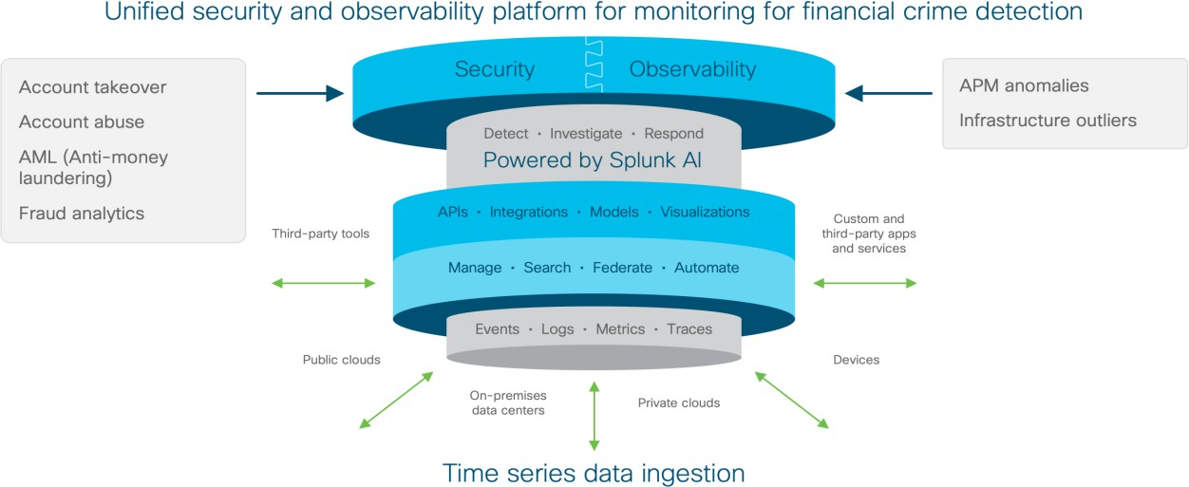

The solution architecture follows a modular and layered design to ensure flexibility and scalability. The frontend layer provides a user-friendly interface for document upload, queries, and visualization. The backend layer manages workflows, authentication, and data processing.
The AI intelligence layer integrates the Gemini Pro model to perform financial analysis and insight generation. The data layer securely stores uploaded documents, analysis results, and user logs. Security mechanisms such as authentication, authorization, and encrypted communication are applied across all layers.
This architecture ensures seamless data flow, efficient processing, and reliable delivery of financial insights while maintaining high performance and data privacy.

PROJECT PLANNING & SCHEDULING

Project Planning
The project planning for Gemini Pro Financial Decoder: Transforming Complex Data into Actionable Insights was carried out by dividing the entire development process into well- defined phases. Each phase was assigned specific tasks and responsibilities among team members to ensure smooth execution and effective collaboration.
The planning process began with requirement gathering and problem analysis, followed by ideation, system design, and technology selection. Subsequently, development activities such as frontend design, backend implementation, AI model integration, and data processing were planned. Testing and validation were scheduled to ensure accuracy, performance, and security of the system. Finally, documentation and deployment planning were included to complete the project lifecycle.

Sprint | Functional Requirement (Epic) | User Story No | User Story / Task | Story Points | Priority | Team Members
Sprint-1 | System Overview | USN-1 | As a user, I want to upload financial documents so that I can analyze financial data automatically | 2 | High | Swetha, Arshiya
Sprint-1 | Document Processing | USN-2 | As a financial analyst, I want the system to extract key financial metrics so that I can review them quickly | 1 | High | Arshiya, Naresh
Sprint-2 | Financial Analysis | USN-3 | As a business owner, I want to view summarized insights and trends so that I can understand financial performance | 2 | Medium | Naresh, Suhail
Sprint-3 | Risk Detection | USN-4 | As an investor, I want the system to highlight risks and anomalies so that I can make informed decisions | 2 | Medium | Suhail, Swetha
Sprint-4 | Visualization & Reports | USN-5 | As a user, I want downloadable financial reports and charts so that I can share insights easily | 1 | Low | Swetha, Naresh

Project Tracker, Velocity & Burndown Chart

Sprint | Total Story Points | Duration | Sprint Start Date | Sprint End Date (Planned) | Story Points Completed | Sprint Release Date
Sprint-1 | 20 | 6 Days | 20-Jan-2026 | 23-Jan-2026 | 20 | 20-Jan-2026
Sprint-2 | 40 | 6 Days | 29-Jan-2026 | 2-Feb-2026 | 20 | 29-Jan-2026
Sprint-3 | 30 | 6 Days | 7-Feb-2026 | 7-Feb-2026 | 20 | 7-Feb-2026
Sprint-4 | 20 | 6 Days | 16-Feb-2026 | 16-Feb-2026 | 20 | 16-Feb-2026

FUNCTIONAL AND PERFORMANCE TESTING
Testing is a critical phase to ensure that the system functions correctly and meets performance expectations. For the Gemini Pro Financial Decoder, both functional and performance testing were conducted to validate accuracy, reliability, and efficiency of financial data analysis.
Model performance testing focuses on evaluating the effectiveness and efficiency of the Gemini Pro model in analyzing financial data and generating actionable insights. The objective is to ensure that the AI model produces accurate, relevant, and timely outputs when processing complex financial documents.

Performance Testing: Model Performance Testing
The model was tested using various financial documents such as balance sheets, income statements, and Excel-based financial data. The key performance parameters evaluated include response time, accuracy of insights, consistency of results, and scalability under multiple requests.

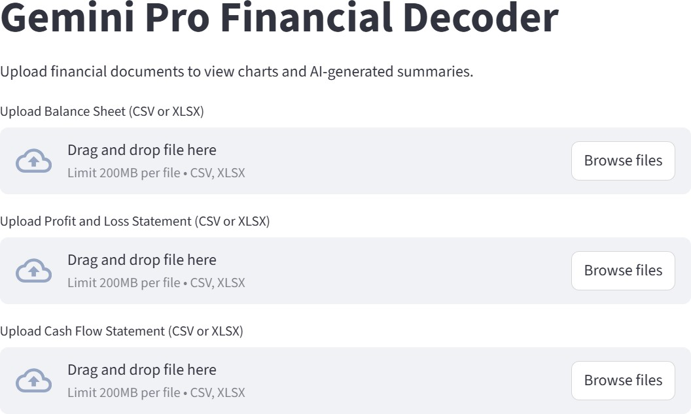

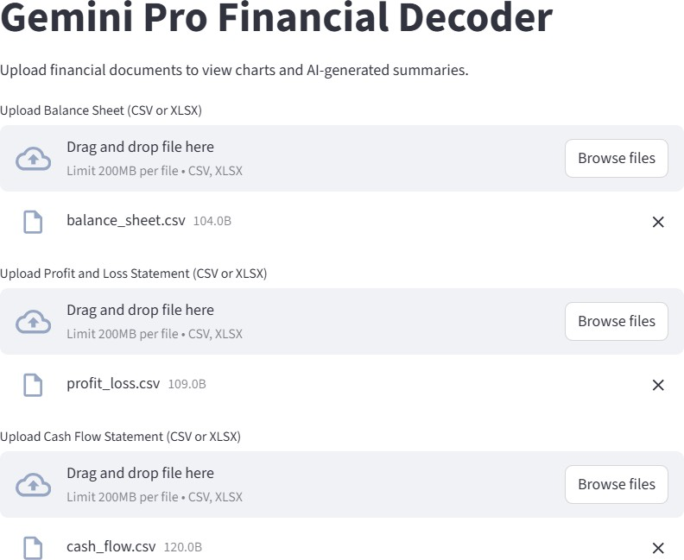

- RESULT

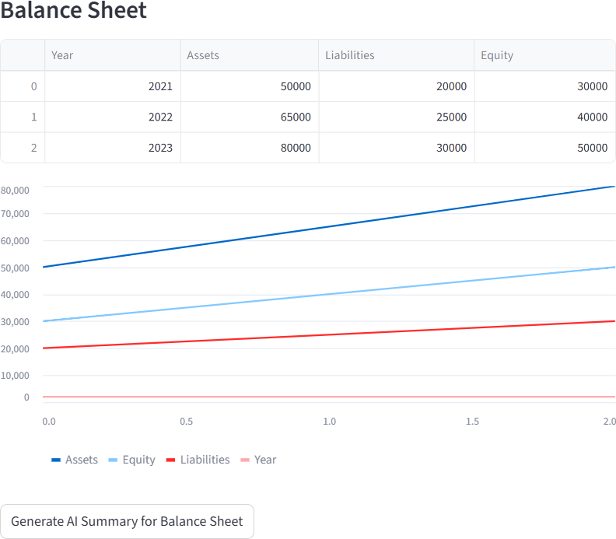

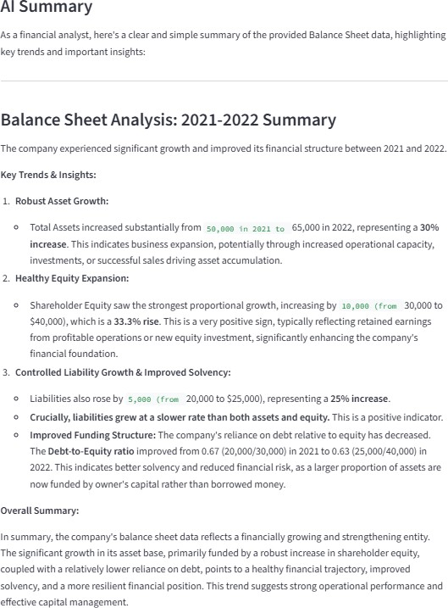

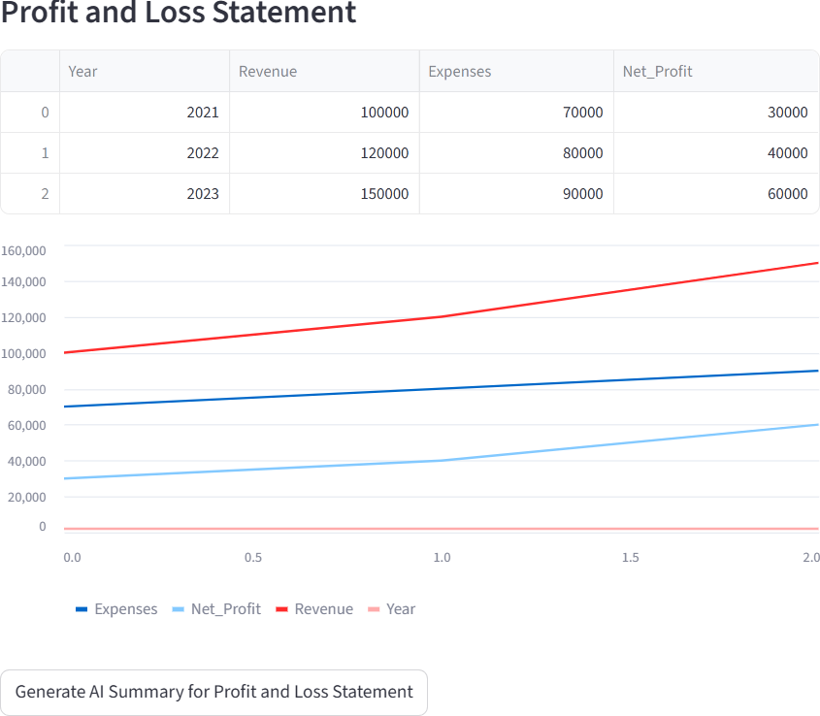

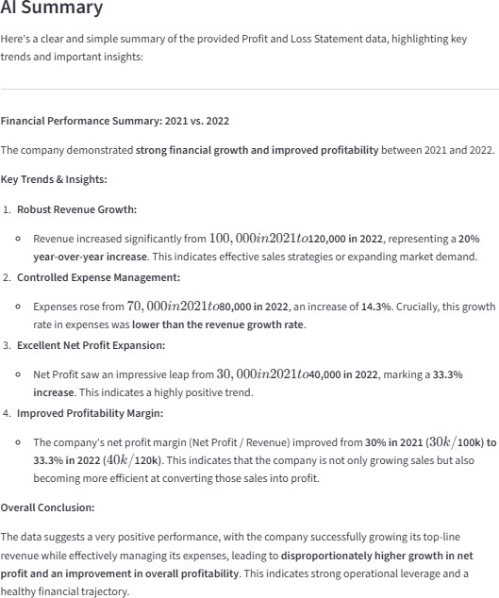

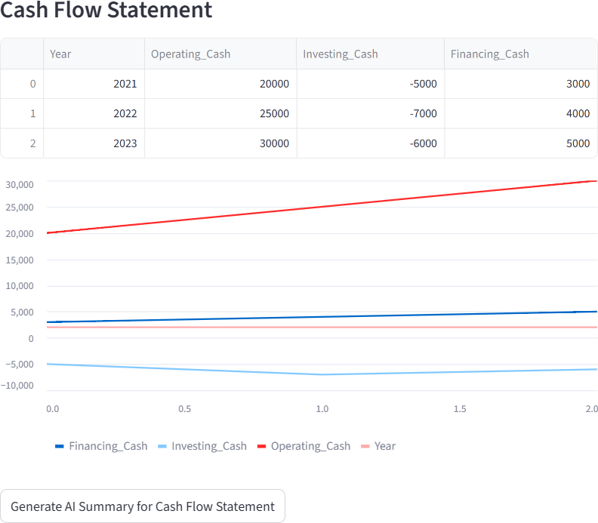

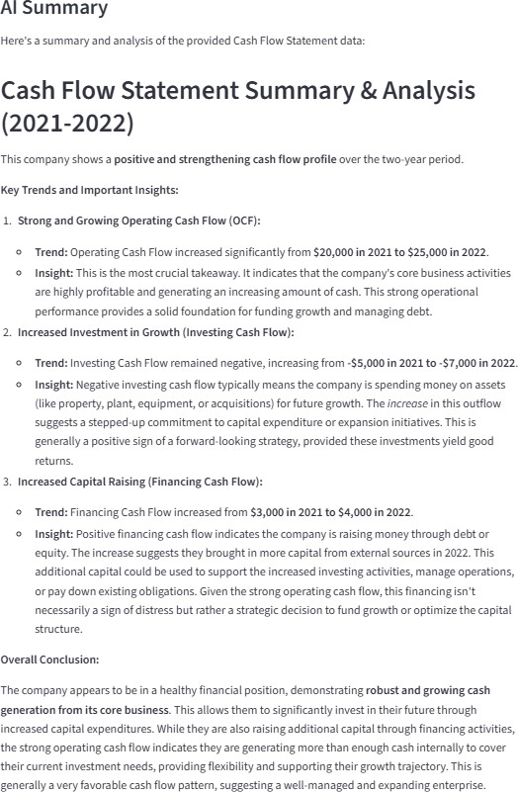

- ADVANTAGES AND DISADVANTAGES
Advantages

Automated Financial Analysis
The system automatically analyzes complex financial documents, reducing manual effort and saving time.

Actionable Insights
Converts raw financial data into clear summaries, trends, and risk indicators to support better decision-making.

User-Friendly Interface
Enables both finance and non-finance users to understand financial information easily.

High Accuracy and Consistency
AI-based analysis minimizes human errors and provides consistent results.

Scalable and Flexible
Supports multiple users and large datasets with cloud-ready architecture.

Secure Data Handling
Ensures data privacy using authentication, encryption, and secure communication.

Disadvantages

Dependency on Data Quality
Poor or incomplete financial data may affect the accuracy of insights.

Internet Dependency
Requires a stable internet connection to access Gemini Pro APIs.

Limited Domain Context
AI-generated insights may require expert validation in complex financial scenarios.

Initial Setup Cost
Deployment and cloud infrastructure may involve initial costs.

CONCLUSION
The Gemini Pro Financial Decoder project successfully demonstrates the application of generative AI in simplifying and automating financial data analysis. The system effectively transforms complex financial documents into clear, actionable insights, enabling users to make informed decisions with greater confidence and efficiency.
By leveraging Gemini Pro, the solution reduces manual effort, minimizes errors, and provides accurate summaries, trend analysis, and risk identification. The user-friendly interface, secure data handling, and scalable architecture make the system suitable for both finance professionals and non-finance users.
Overall, this project highlights the potential of AI-driven financial analytics in enhancing decision-making processes and improving accessibility to financial insights. The proposed system serves as a reliable, efficient, and intelligent tool for modern financial analysis and decision support.

FUTURE SCOPE
The Gemini Pro Financial Decoder has significant potential for future enhancements and expansion. As financial data and AI technologies continue to evolve, several improvements can be incorporated to increase the system’s functionality and impact.
In the future, the system can be extended to support real-time financial data integration from stock markets, banking systems, and accounting software. Advanced predictive analytics and forecasting features can be added to provide future financial trends and risk predictions.
Integration with additional AI models and domain-specific financial knowledge bases can further improve the accuracy and depth of insights.
The system can also be enhanced with multi-language support, making it accessible to a wider user base. Mobile application development, voice-based interaction, and personalized recommendation features can improve usability. Additionally, stronger compliance mechanisms and explainable AI features can be incorporated to meet evolving regulatory requirements and increase user trust.
Overall, the future scope of this project highlights its adaptability, scalability, and potential to become a comprehensive AI-driven financial decision support system.

APPENDIX
app.py:
import streamlit as st import pandas as pd import numpy as np import os
import google.generativeai as genai

#
# PAGE CONFIG (MUST BE FIRST) #
st.set_page_config(page_title="Gemini Pro Financial Decoder")

#
# APP TITLE (THIS WAS MISSING) #
st.title(" x Gemini Pro Financial Decoder")
st.write("Upload CSV files to generate AI-powered financial insights.")

#
# API KEY (CORRECT WAY) #
API_KEY = os.getenv("GOOGLE_API_KEY")

if not API_KEY:
st.error("+ GOOGLE_API_KEY not set") st.stop()

genai.configure(api_key=API_KEY)
model = genai.GenerativeModel("gemini-pro")

#

# FILE UPLOAD #
st.subheader("ç†v. Upload Financial Files")

balance_file = st.file_uploader("Balance Sheet CSV", type="csv") pl_file = st.file_uploader("Profit & Loss CSV", type="csv") cash_file = st.file_uploader("Cash Flow CSV", type="csv")

#
# FUNCTIONS #
def load_csv(file): if file:
return pd.read_csv(file) return None

def generate_summary(df, name): if df is None:
return "⚠ No file uploaded"

prompt = f"""
Analyze this {name} data and give:
- Key insights
- Strengths
- Weaknesses

Data:
{df.head(5)} """
response = model.generate_content(prompt) return response.text

def visualize(df, title): if df is None:
return

st.subheader(title) st.dataframe(df)

num = df.select_dtypes(include=np.number) if not num.empty:
st.line_chart(num)

#
# BUTTON (THIS EXECUTES UI) #
if st.button("s'.¸˙•7 Generate Report"): with st.spinner("Analyzing..."):
balance_df = load_csv(balance_file) pl_df = load_csv(pl_file)
cash_df = load_csv(cash_file)

st.success("⬛ Analysis Complete")

st.markdown("## ]H_ Balance Sheet") st.write(generate_summary(balance_df, "Balance Sheet")) visualize(balance_df, "Balance Sheet Data")

st.markdown("## _ ]H Profit & Loss") st.write(generate_summary(pl_df, "Profit & Loss")) visualize(pl_df, "Profit & Loss Data") st.markdown("## _H ] Cash Flow") st.write(generate_summary(cash_df, "Cash Flow")) visualize(cash_df, "Cash Flow Data")

requorements.txt:
  - streamlit
  - pandas
  - matplotlib
  - langchain
  - langchain-google-genai
  - google-generativeai

DATASET:
- Balance_sheet.csv
- Profit_and_loss.csv
- Cash_flow.csv
Demo video: https://drive.google.com/file/d/1Zutc4sm3RmHHhdq71-T-KbJiC2C6bw80/view?usp=sharing
Github : https://github.com/kpswetha26/Gemini-pro-financial-decoder-Transforming-complex-data-into-actionable-insights

